Unity Manual > Advanced > Web Player Debugging

Web Player Debugging
There might be times during development when you need to obtain information from the logs of a webplayer you've built. Usually you need to see these files when your web player has experienced some problem, and you need to see where exactly the problem occurred.

Mac OS X Log Location
On Mac OS X, all web player log files are output to the console log: ~/Library/Logs/Unity/Player.log. This log can be accessed via standard Console.app utility application, or from Unity editor menu Help -> Open Player console log.

Windows Log Location
On Windows, the web player log files are stored in the TEMP directory. This can vary slightly from computer to computer. Most commonly, the files are located in C:\Documents and Settings\(current user)\Local Settings\temp\UnityWebPlayer\log
Please note: The Local Settings folder is hidden by default. In order to see it, you must enable viewing of hidden folders from Tools->Folder Options...->View (tab).
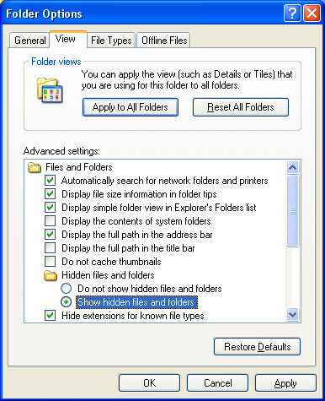
Enabling viewing of hidden folders in Windows XP
Inside this folder, you will see text files that begin with either "log_" or "manager_". Viewing these files will show you all the Debug.Log calls. You can safely delete the files inside this folder at any time.

Windows Vista/IE7 Location
If the user is running Vista and using IE7 and UAC is enabled, the log files will be located in a different place. This is due to the "enhanced" security of Windows Vista and IE7. That location is C:\Users\(current user)\AppData\Local\Temp\Low\UnityWebPlayer\log
Please note: The AppData folder is hidden by default. In order to see it, you must enable viewing of hidden folders from Tools->Folder Options...->View (tab). The Tools menu is hidden by default, but can be displayed by pressing the Alt key once.
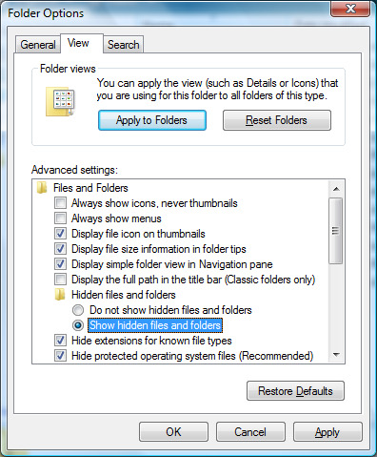
Enabling viewing of hidden folders in Windows Vista

